**Adriano Magnifico M .Ed. P.Log.**

Life Philosophy

Our stories are full of gifts and talents – commitment, space and mentorship make them come true.

Most Proud of

* Teacher-coach-workshop facilitator of +4000 students
* Achieved +80% student focus for post-high school plans
* Designer of multi award- winning school career programs
* Speaker on innovative programming & career development at over 40 local, provincial & national conferences
* Husband, father, son, uncle, brother, friend

Designer of Useful Tools

* LEAN Start-up Canvas for entrepreneurship
* LEAN Career Canvas for career development
* Résumé/cover letter website, [www.schmegley.weebly.com](http://www.schmegley.weebly.com)
* Course writer: *Technical Communication*, *Logistics Mgmt*., *Drivers of Innovation, Creativity and Innovation*

Giving Back

* 20-year Volunteer Pin with *Special Olympics Manitoba*
* 2017 Premier’s Volunteer Service Award Nominee
* *Manitoba Start* volunteer career development facilitator
* School & community coach for 30 years and over 60 teams
* *Junior Achievement* *MB* student entrepreneurship mentor
* *Centrallia*—World Trade Centre and Wpg. & Chamber World B2B event – volunteer & student volunteer recruiter
* *Manitoba Underdogs Rescue* Multi-Foster Family

Special Achievements

* Multi Award-Winning educator for curriculum design, innovative programming and short story writing
* Published writer on language arts and career development
* Coach/Mentor for over 30 multi award-winning students in C.M.E. Innovation Challenges, U of Manitoba Venture Championships, Loran & Schulich Scholarships & Junior Achievement teams

Education and Training

* **Bachelor of Ed**. in English, History, Drama U of Manitoba
* **Masters Degree** in Education, U of Manitoba, Durham U.K.
* **Logistics Designation (P.Log.)** Logistics Institute, Toronto
* **Advanced Placement** **Training** **(AP),** Carlton College, MN,
* **Italian Language Program**, Perugia University, Italy
* *Stephen Covey 7-Habits Signature* Training, Winnipeg
* *Ken Blanchard Situational Leadership* Training, Toronto

Curriculum Designer ★ Volunteer ★ Mentor ★ Facilitator

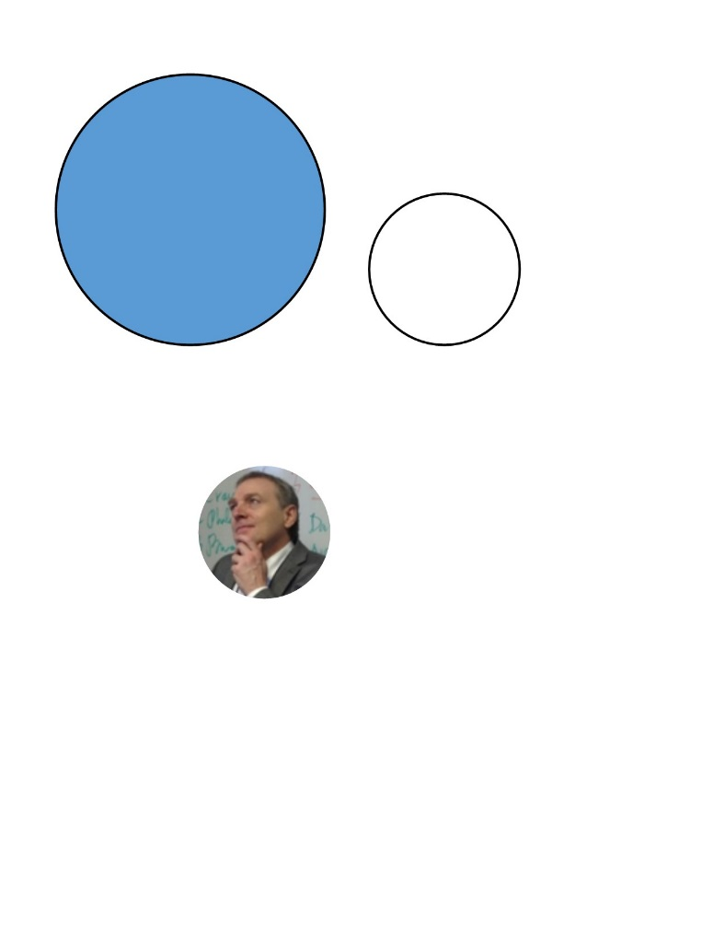th[1]th[1]

Professional Experience

Career & Entrepreneurship Consultant

**Louis Riel School Division** 2015 – present Winnipeg

* Vision and manage Career Development Committee creating 3-year grade 8-12 divisional career development plan
* Conceptualize and lead *Career Cohorts* in 7 high schools, meshing traditional courses with career development & entrepreneurial activities
* Plan and implement Career & Post-Secondary Symposium (CAPS) for over 700 parents, students, universities, businesses
* Implement annual Tigers’ Den Entrepreneurship Conference with 35 businesses and 75 students from 8 high schools

MATE Co-President

**Manitoba Association of Teachers of English** 2013 – present

* Member of MATE for 10 years; work with Executive Team to plan and implement yearly conference for 400+ delegates, 20+ workshops, keynotes, supervise conferences as site coordinator in high schools
* Oversaw redevelopment of MATE website, created Mentor-tutor program, develop meeting agendas, chair meetings, delegate tasks

Community Correspondent/Writer

**Canstar News, The Lance** 2012-present

* Regular columnist-writer of +60 human interest articles for Winnipeg Free Press community newspaper
* Interviewed interesting people, reported on events and highlighted innovative or unusual business products/services in St. Boniface-St. Vital

Engagement Coordinator

**Louis Riel School Division** 2012 – 2015 Winnipeg

* Designed and Implemented initiatives with at-risk students, including creation of QUEST employability skills program for at-risk students
* Co-created summer literacy program, ASPIRE, for students in low socio-economic areas, expanded from 1 to 4 schools over 3 years
* Completed detailed research and facilitated on engagement levels in school and the workplace

Director, Career Internship Program

**River East Collegiate, Windsor Park Collegiate** 1995-2012 Wpg.

* Managed and supervised over 250 student interdisciplinary projects that involved partnerships with businesses and professional communities
* Managed Federal pilot project budget of $250,000
* Developed award-winning curriculum with using English Language Arts as a hub for Innovation, Career Development and Entrepreneurship



39 Balsam Place Winnipeg MB R2H 1K8

Winn

204-293-9591

Winn



amagnif@mymts.net

Winn

[www.linkedin.com/in/adriano-magnifico-m-ed-4392391b/Winn](http://www.linkedin.com/in/adriano-magnifico-m-ed-4392391b/Winn)

th[1]

@anomagnifico

@anomagnifico

